Chapter 14, Solution 39.

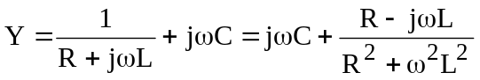

At resonance, 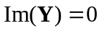, i.e.
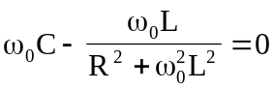
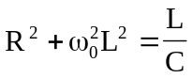
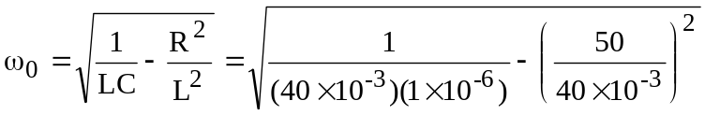
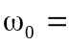4.841 krad/s

